# TABLE OF CONTENTS

|  |  |  |
| --- | --- | --- |
|  | **TITLE** | **PAGE** |
|  | **ABSTRACT** | **ii** |
|  | **INTRODUCTION**    **EXISTING SYSTEM**    **PROPOSED SYSTEM**    **METHODOLOGY**    **IMPLEMENTATION**    **CONCLUSION** | **ii**  **ii**  **ii**  **iii**  **iv**  **vi** |

**ABSTRACT**

Brrrgrrr - A online website that sells burgers. It suggests users to not only customize their burgers by adding or removing ingredients but also create their own burger from the ingredients in stock.

**INTRODUCTION**

Burger is a striking free food website template with a nifty design that will water your mouth. If you are looking to create an online presence for your fast-food or burger bar business, you better not miss checking out – hence the name – Burger. The tool sports a responsive and cross-browser compatible layout that ensures a first-class performance at all times. Moreover, this superb site also sports many features and functions that will put you right on track.

From full-width slider, sticky header and drop-down menu to food menu, testimonials and social media icons, it is all part of the bundle. With the included blog pages, you can also start sharing different tips and information, as well as spread the word for special announcements and whatnot.

**EXISTING SYSTEM**

Currently all the websites will support only ordering a type of a burger like veg.burger, non-veg burger etc. The user can select only the type of the burger and not its ingredients. Also, all the other websites are having heavy skins which affects the performance of that website. And so in the high demand , the website crashes and may not respond.

**PROPOSED SYSTEM**

In my website the user can able to select a particular ingredient to his/her ordering burger and the may change according to which ingredient the user selects to their burger. Also, I am using a very light skin on my website which greatly improves the performance of the website. And so in the high demand my website will not crash and it will respond to the user even in heavy demand or unstable internet also.

**METHODOLOGY**

I have implemented my project using front-end project using HTML, CSS, Bootstrap, JavaScript. I have divided each segment into each html files and I linked it with javascript and css. If you click on the options, it will redirect you to a new sections of that website, where you can browse and order things. Also, according to your ordered items and ingredients, the prices of the product may vary.

**MODULE DESCRIPTION**

**Hyper Text:** HyperText simply means "Text within Text." A text has a link within it, is a hypertext. Whenever you click on a link which brings you to a new webpage, you have clicked on a hypertext. HyperText is a way to link two or more web pages (HTML documents) with each other.

**Markup language:** A markup language is a computer language that is used to apply layout and formatting conventions to a text document. Markup language makes text more interactive and dynamic. It can turn text into images, tables, links, etc.

**Web Page:** A web page is a document which is commonly written in HTML and translated by a web browser. A web page can be identified by entering an URL. A Web page can be of the static or dynamic type. **With the help of HTML only, we can create static web pages**.

* CSS stands for Cascading Style Sheet.
* CSS is used to design HTML tags.
* CSS is a widely used language on the web.
* HTML, CSS and JavaScript are used for web designing. It helps the web designers to apply style on HTML tags.

JavaScript (js) is a light-weight object-oriented programming language which is used by several websites for scripting the webpages. It is an interpreted, full-fledged programming language that enables dynamic interactivity on websites when applied to an HTML document. It was introduced in the year 1995 for adding programs to the webpages in the Netscape Navigator browser. Since then, it has been adopted by all other graphical web browsers. With JavaScript, users can build modern web applications to interact directly without reloading the page every time. The traditional website uses js to provide several forms of interactivity and simplicity. Although, JavaScript has no connectivity with Java programming language. The name was suggested and provided in the times when Java was gaining popularity in the market. In addition to web browsers, databases such as CouchDB and MongoDB uses JavaScript as their scripting and query language.

JavaScript is used to create interactive websites. It is mainly used for:

* Client-side validation,
* Dynamic drop-down menus,
* Displaying date and time,
* Displaying pop-up windows and dialog boxes (like an alert dialog box, confirm dialog box and prompt dialog box),
* Displaying clocks etc.

Bootstrap is the popular HTML, CSS and JavaScript framework for developing a responsive and mobile friendly website.

**IMPLEMENTATION**

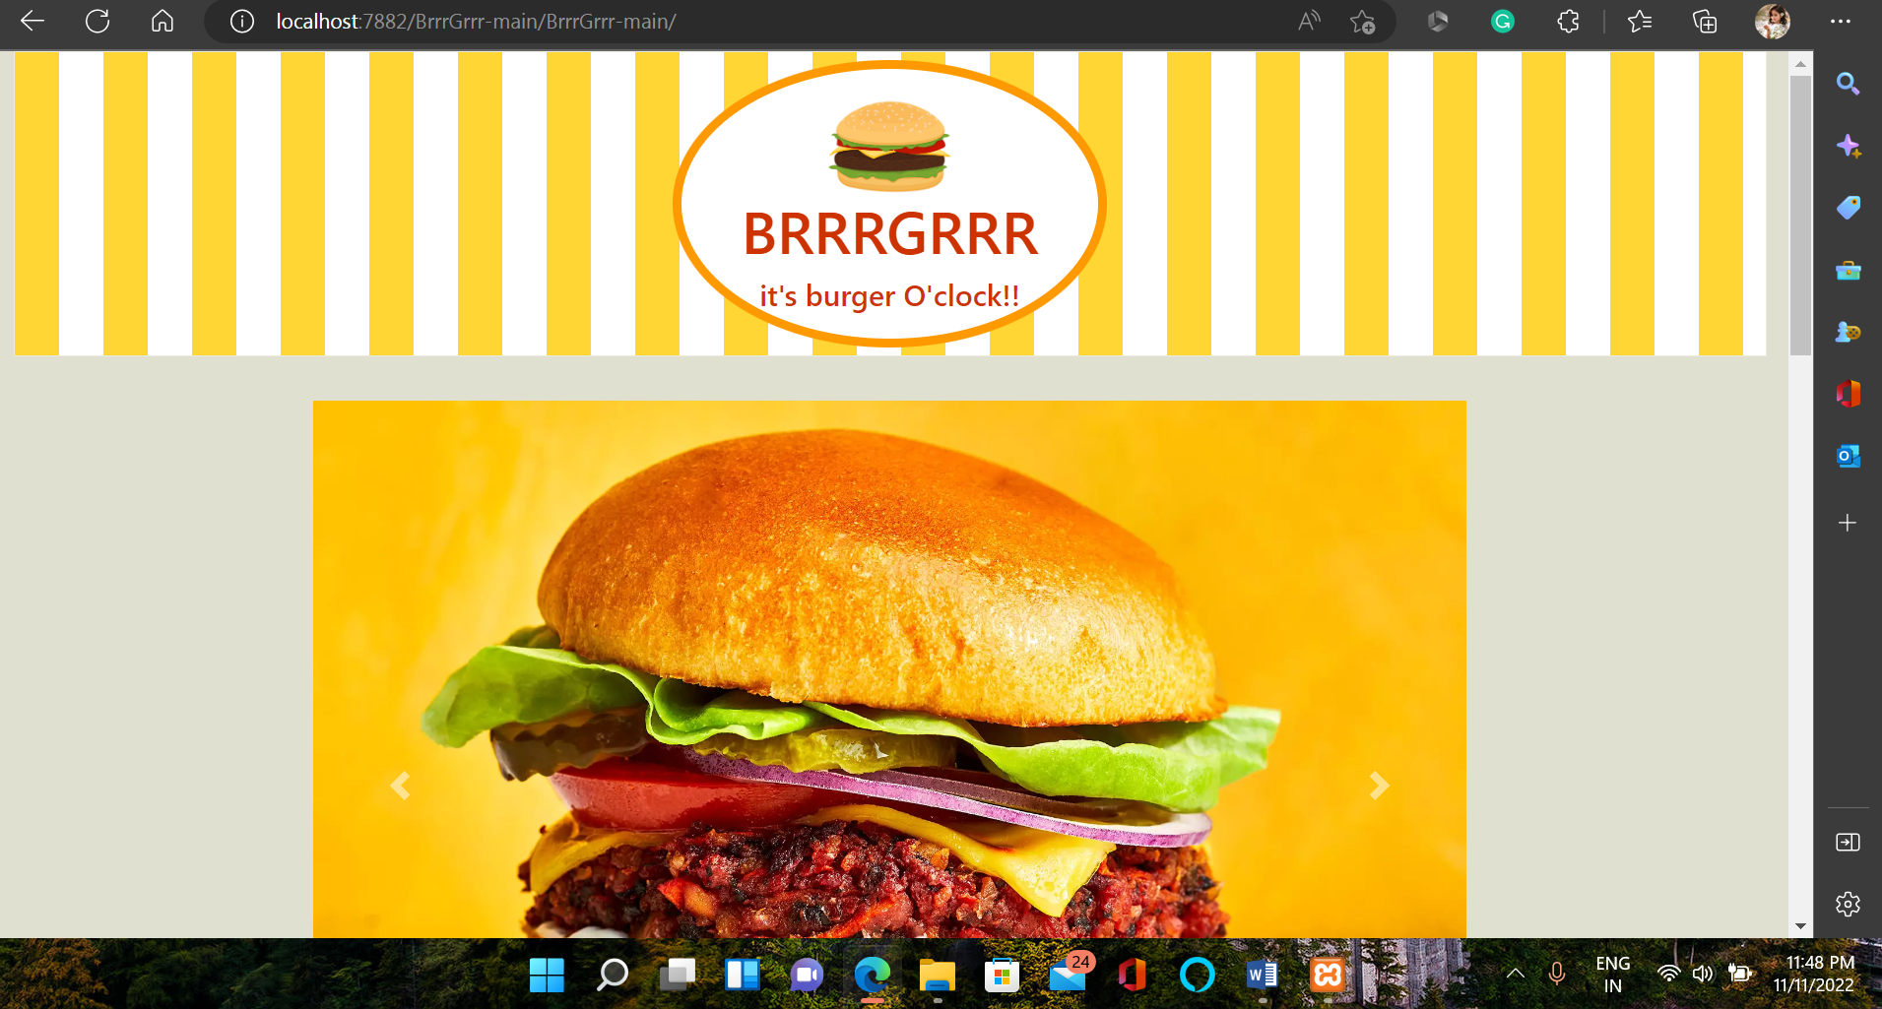

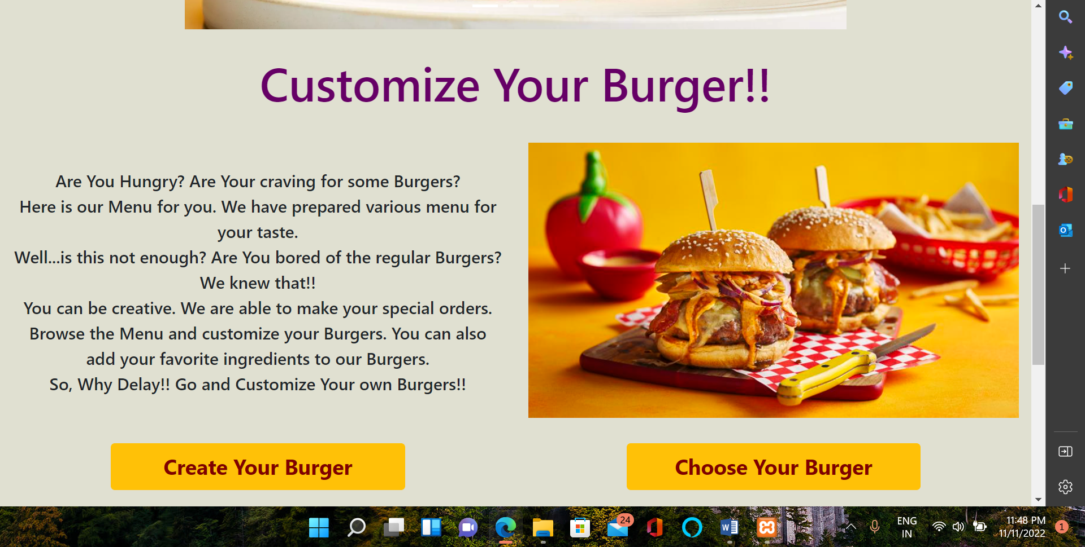`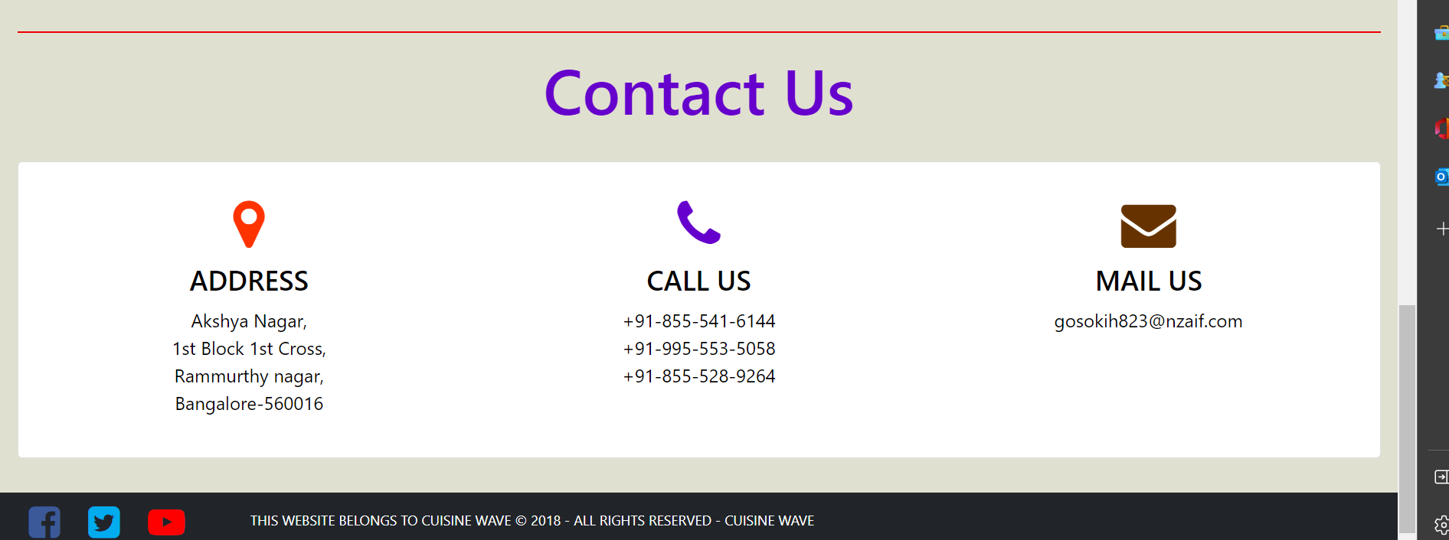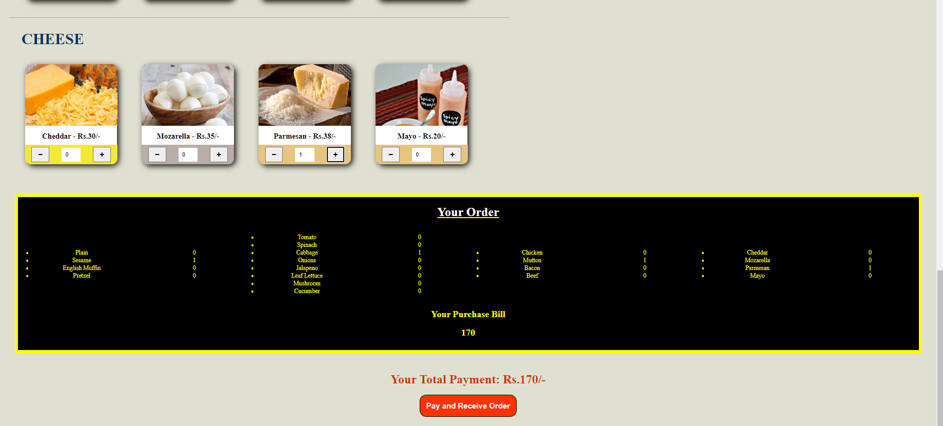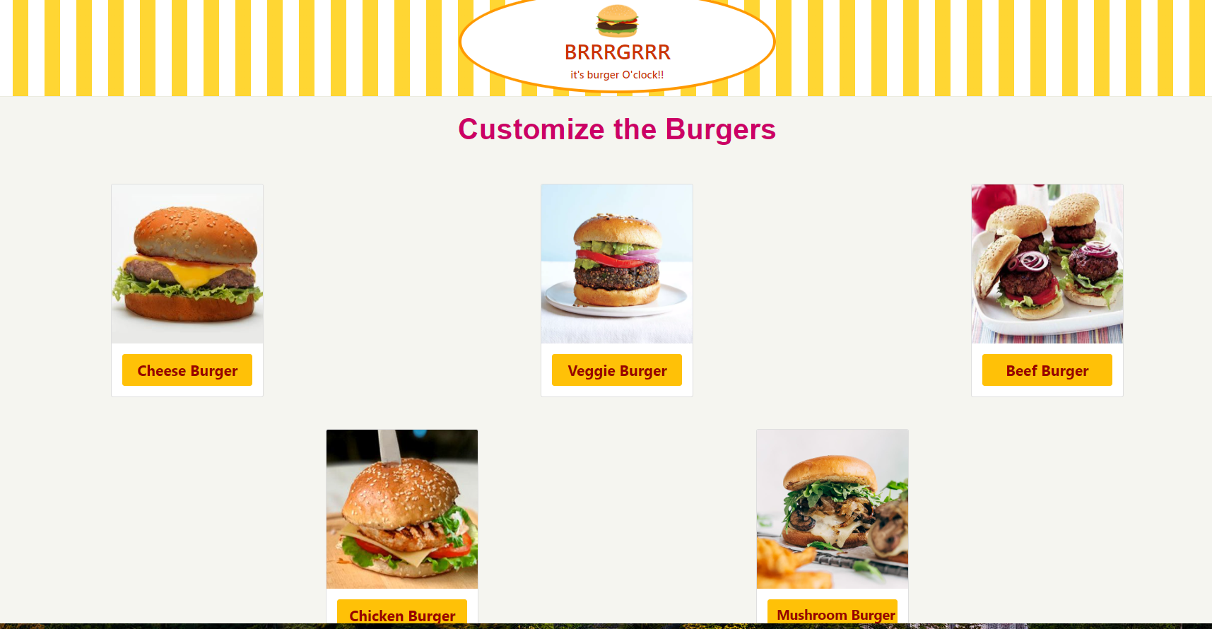

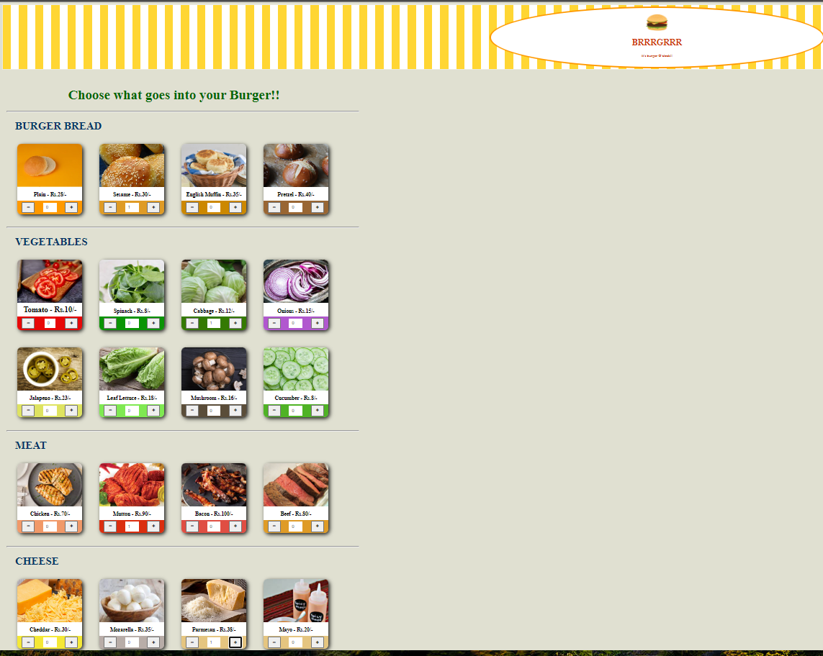

**CONCLUSION**

Thus, we have created a online website that sells burgers. It suggests users to not only customize their burgers by adding or removing ingredients but also create their own burger from the ingredients in stock. Currently, I have developed only the front end to this website but in the nearby future if you develop the backend then it would be more beneficial.